Smile Anti-Bullying Service
Focus on Mental Health and Wellbeing - Training Menu 2023

In house training

Staff
Lunchtime Supervisor Training Session – 1hr after lunch
(cost to be agreed depending on numbers/travel)

Students
Peer Support or Mental Health Ambassador Training Session – 2 hours
Cyber bullying ambassadors – 2 hours
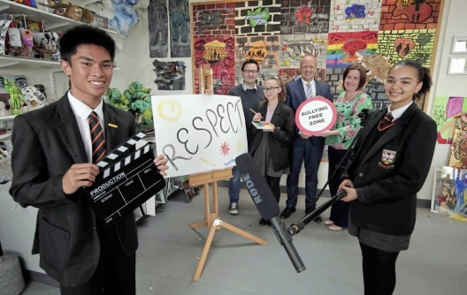
Peer Mediation Training – 2 hours
Class Friendship Workshop – 1 hr
Whole school anti-bullying roadshow – 1 hr
E Safety and Cyber Bullying – 1 hr
Girl Friendship Workshop – 1hr
Boy Friendship Workshop – 1hr
Individual Pupil Support – 2hrs – 4 pupils (half hour each)

School anti-bullying support coordinator - Discounted block booking of days across the term/year to visit and support individual students and facilitate small group work if suitable as well as supporting school with their whole school emotional health and well-being plans. I will recruit, train and maintain a peer support scheme as well as assisting the school with achieving The BIG Award. I can also hold awareness raising lessons, assemblies and link in with the school council.
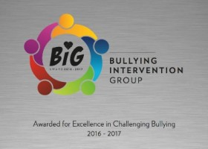
BIG Award (National Anti-Bullying award and Resources)
Join BIG to receive our online bullying reporting system for pupils (SOS), BIG Audit Survey System, BIG toolkit, anti-bullying week pack, girl bullying pack, peer support materials, regular newsletter to a named anti-bullying leader in school, resources for staff and the opportunity to gain our national award with support to guide you.
Example price for annual membership - £182 for a primary school with under 500 pupils.
Visit www.bullyinginterventiongroup.org for further information.

Training costs – 2 hour minimum sessions.
2 hours | £275
6 hr SLA | £750
Block booking at secondary or special schools (10 or more days) | £290 per day
Email: vicki.lydon@bigaward.org.uk | Phone: Vicki - 07870 499275

Travel is charged at 50p per mile.

