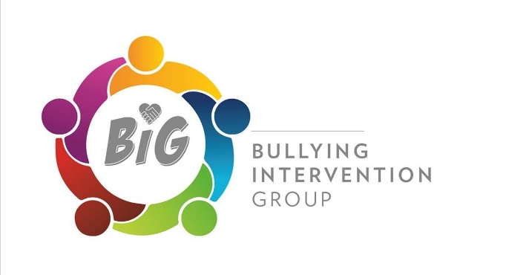

BIG Award Information Pack

- What is the BIG Award for Excellence in Challenging Bullying?

The BIG Award is available for schools, colleges, children’s homes and other organisations which children and young people attend. The criteria are carefully set so that the organisation has a robust set of anti-bullying strategies in place and has a consistent and effective plan to tackle bullying. Bullying can happen anywhere and having pro-active work in place can make a huge difference to the lives of young people, so that they can socialise and learn in a happy and inclusive environment. We are a not for profit, well established (2011) organisation receiving no outside funding.

- What is included in my BIG Award annual membership fee?

Your annual membership fee includes access to the member area of our website with all of our anti-bullying resources, our SOS Reporting Tool, our BIG Survey service including audit tools and analysis and our BIG Award including assessment, logo, certificate and wall plaque.

Also included:
*An anti bullying pack in anti bullying week
*Regular newsletters
*Peer support training materials
*Girl friendship issues and bullying pack
*React, Respond, Restore - Toolbox of strategies for schools and settings

We are also always at the end of a phone or email for advice and guidance. We pride ourselves on our excellent customer service.

- What is the annual cost to join BIG?
Primary School under 500 pupils - £230 or over 500 pupils £350
Middle school £400
Secondary School under 1200 pupils - £370 or over 1200 pupils £480
Special School under 100 pupils - £150
Children’s Home - £150
We can arrange a discount for a group.

- What are the criteria to achieve the BIG Award for Excellence in Challenging Bullying?

- An anti-bullying focus group
- A robust, up to date anti-bullying policy
- A Peer Support scheme (not special schools)
- Regular anti-bullying awareness raising
- Including parents in anti-bullying work
- Anti- bullying staff training
- Recording and monitoring of bullying incidents
- A testimonial from a young person

- How long does it take to achieve the BIG Award?

You may have all of the above in place already. There is no deadline to complete your online portfolio, it will take as long as it takes you to have all of the required strategies established in your organisation.

- What do we receive when we achieve it?

Once we are satisfied you have met all of the criteria, you will receive a logo, a certificate, a certificate for the young people involved and a beautiful wall plaque. Your organisation or school will be added to the achievers list on the website.

- How long is the BIG Award valid for?
We ask you to complete a new portfolio every year. The portfolio is simple to complete - we like to know that your good work is consistent.

- Do you provide support?
Yes, we have lots of BIG Guides you can click on as you complete the online portfolio, we are also always around to speak to or email if you want advice. We also provide a template portfolio and anti-bullying policy to help you.

- How do we join BIG or find out more?
Just email val.mcfarlane@bigaward.org.uk or go to our website www.bullyinginterventiongroup.org or give us a call 07502189658.

